**Project Design Phase-II**

**Data Flow Diagram & User Stories**

|  |  |
| --- | --- |
| Date | 03 October 2022 |
| Team ID | PNT2022TMID36162 |
| Project Name | Fertilizer recommendation system for disease prediction |
| Maximum Marks | 4 Marks |

**Data Flow Diagrams:**

A Data Flow Diagram (DFD) is a traditional visual representation of the information flows within a system. A neat and clear DFD can depict the right amount of the system requirement graphically. It shows how data enters and leaves the system, what changes the information, and where data is stored.

Level 0 DFD diagram

[**(Simplified)**](https://developer.ibm.com/patterns/visualize-unstructured-text/)

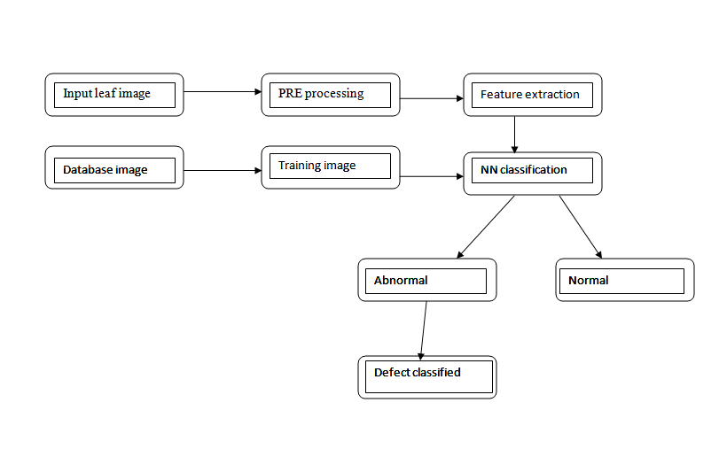

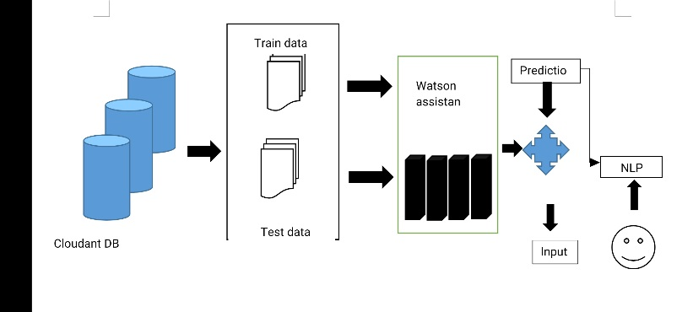

**User Stories**

Use the below template to list all the user stories for the product.

| **User Type** | **Functional Requirement (Epic)** | **User Story Number** | **User Story / Task** | **Acceptance criteria** | **Priority** | **Release** |
| --- | --- | --- | --- | --- | --- | --- |
| Customer (Mobile user) | Registration | USN-1 | As a user, I can register for the application by entering my email, password, and confirming my password. | I can access my account / dashboard | High | Sprint-1 |
|  |  | USN-2 | As a user, I will receive confirmation email once I have registered for the application | I can receive confirmation email & click confirm | High | Sprint-1 |
|  |  | USN-3 | As a user, I can register for the application through Facebook | I can register & access the dashboard with Facebook Login | Low | Sprint-2 |
|  |  | USN-4 | As a user, I can register for the application through Gmail |  | Medium | Sprint-1 |
|  | Login | USN-5 | As a user, I can log into the application by entering email & password |  | High | Sprint-1 |
|  | Dashboard |  | As a user u can see the improvement as a graph |  | Medium | Sprint-2 |
| Customer (Web user) | User input |  | The input is given as a image or a dataset |  | Medium | Sprint-1 |
| Customer Care Executive | Feature extraction |  | the process of transforming raw data into numerical features that can be processed while preserving the information in the original data set. |  | High | Sprint-1 |
| Administrator | prediction |  | Leaves are affected by bacteria, fungi, virus, and other insects. Support Vector Machine (SVM) algorithm classifies the leaf image as normal or affected |  | Low | Sprint-2 |
|  | classifier |  | Artificial neural network is used to assign a class label to data input |  | Medium | Sprint-1 |
|  |  |  |  |  |  |  |
|  |  |  |  |  |  |  |